
Alton Winter Beer Festival
Sat 11th Feb 2006

Lunchtime 11 to 3pm and Evening 7 to 11pm
Sponsored by Triple fff

at the

Alton Maltings Centre

Over 40 real ales, live music and good food

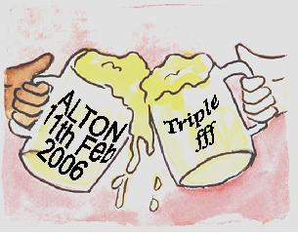

Tickets £5
(£7 on the door) Available from:
Cavern Bar (Alton Community Centre),
Railway Arms and Alton Maltings Centre,

Tel 01420 89418 e mail tickets@altonbeerfestival.co.uk
All profits to local charities
www.altonbeerfestival.co.uk

